BVRI Photometric Observations, Light Curve Solutions and
Orbital Period Analysis of BF Pav

Atila Poro¹, Mark G. Blackford², Fahri Alicavus^{3,4}, Fatemeh Davoudi¹, Edwin Budding⁵,
PegahSadat MirshafieKhozani¹, Eduardo Fernández-Lajús^{6,7}, Behjat Zarei Jalalabadi¹,
Jabar Rahimi¹, Farzaneh Ahangarani Farahani¹

¹The International Occultation Timing Association Middle East section, Iran, info@iota-me.com
²Variable Stars South (VSS), Congarinni Observatory, Congarinni, NSW, Australia 2447, Australia
³Çanakkale Onsekiz Mart University, Faculty of Arts and Sciences, Department of Physics, 17020, Çanakkale, Turkey
⁴Çanakkale Onsekiz Mart University, Astrophysics Research Center and Ulupınar Observatory, 17020, Çanakkale, Turkey
⁵Carter Observatory, 40 Salamanca Rd, Kelburn, Wellington 6012, New Zealand
⁶Instituto de Astrofísica de La Plata (CCT La Plata-CONICET-UNLP), La Plata, Argentina
⁷Facultad de Ciencias Astronómicas y Geofísicas, Universidad Nacional de La Plata, Paseo del Bosque, B1900FWA, La Plata, Argentina

Abstract
The new ephemeris and light curve analyses of a W UMa-type eclipsing binary BF Pav are presented in this study by synthesizing the mid-eclipse times and using the former observations. The period changes of the binary system was obtained using the Wilson-Devinney code with the system’s eight nights of observation taken in BVRI filters from two observatories in Australia and Argentina. The light curve of the system was modeled with a cold spot on the primary component and the results of this analysis demonstrate that BF Pav is a contact binary system with a photometric mass ratio $q=1.459±0.020$, a fillout factor $f=9.9\text{\%}$, and an inclination of $89.31±0.49deg$. By using the distance modulus formula, the distance of BF Pav was calculated to be $d=243±18pc$ which is in good agreement with the Gaia DR2 distance. From the O-C analysis, we found a continuous period increase at a rate of 0.173277$×{10}^{−7}\frac{days}{year}$ which corresponds to a period increase of 0.149 s ${century}^{−1}$. The mass of the primary binary component was also determined using two different methods which result close to each other.

Key words: techniques: photometric — binaries: eclipsing — stars: individual (BF Pav)

1. INTRODUCTION
W UMa-type binary systems have short orbital periods less than a day and they show continuous light variations (Dryomova and Svechnikov 2006). These systems are abundant in binary stars (Okamato and Sato 1970). They include two stars usually surrounded by a common envelope resulting from a mass overflowing from the Roche lobe of one binary component (Smith 1984). Despite many studies that have been done on the basis of the Common Connective Envelope (CCE) in recent years (Qian 2003), many details still undetermined about the evolutionary state of the contact binaries due to extreme spectral line broadening for achieving spectra analyzing (Yang et al. 2015). For justifying the contact phase in contact binaries, Stepień (2006) suggested the angular momentum loss through magnetic wind, whereas Qian (2018) suggested the transmission of a large extent of angular momentum to a third body. So it is efficient to investigate the formation and structure of W Uma-type contact binaries for studying physical processes in these systems with more details. We can find valuable details about mass transfer, mass loss, and also the evolutionary state of close binaries by perusing orbital variations of them.
The BF Pav binary system, which is located in the constellation of Pavonis in the Southern Hemisphere Sky, is a variable star of W UMa-type with an approximate period of 0.30231864 days and G8 Spectral type (Gonzalez et al. 1996). Its apparent magnitude in the V-band is 12.17 (APASS9). The variability of BF Pav was discovered by Shapley in 1939 and the first photoelectric light curve was obtained by Hoffman (1981). Although these observations did not cover the complete orbital period, the observer derived a period of 0.3056 days (Gonzalez et al. 1996). Between 1987 and 1993, BF Pav was observed photoelectrically in the UBV filters in the observational program of Southern Short-Period Eclipsing Binaries to determine the times of minima, photometric and absolute parameters. The photometric solution resulted with a mass ratio of $q=1.4±0.2$, a fillout factor equals to 10%, and efficient thermal contact between the components, $ΔT100K$ (Gonzalez et al. 1996). Dryomova and Svechnikov (2006) found the rate of period change of BF Pav to be $p˙=1.62×{10}^{−7}\frac{days}{year}$ in their study by checking the variation in the orbital period of W Uma-type contact systems. Zhang et al. (2015) noted that BF Pav has a similar period increase to GK Aqr.
In this paper, we present a new ephemeris based on our observations as well as new period change analysis and light curve solutions to investigate the evolutionary state of BF Pav in more details.

2. OBSERVATION AND DATA REDUCTION
The observation of the BF Pav was carried out in September 2017, April 2018, August and June 2019, and July 2020 and a total of 3517 images were taken during eight nights. 2054 images were taken with a 14-inch Ritchey Chretien telescope and SBIG STT3200-ME CCD equipped with Astroden Johnson-Cousins BVRI Filters at the Congarinni Observatory which is located in Australia with geographical coordinates 152° 52´ East and 30° 44´ South and 20 meters above the mean sea level. Each frame was recorded at $2×2$ binning with 50 seconds exposure time in each filter and CCD temperature set at -15°C. Also 1463 images were taken with the 2.15 m “Jorge Sahade” telescope and VersArray 2048B, Roper Scientific cryogenic CCD with V filter and each frame was recorded at 5×5 binning with 15 seconds exposure time at the Complejo Astronomico El Leoncito (CASLEO) Observatory located in Argentina with geographical coordinates 69° 18´ West and 31° 48´ South and 2552 m above the mean sea level.
GSC 8770-1511 was chosen as a check star and 8 stars were chosen as comparison stars with appropriate apparent magnitude in comparison to BF Pav. The general characteristics of BF Pav with the comparisons and the check star are shown in Table 1.

Table 1 Characteristic of the Variable star, the Check star, and the Comparison stars (from: SIMBAD and Vizier-APASS9).
Star type | Star name | RA. (J2000) | DEC. (J2000) | Magnitude (V)
Variable | BF Pav | 18 45 39.32 | -59 38 25.87 | 12.17
Comparison₁ | GSC 8770-1107 | 18 45 30.01 | -59 32 34.9 | 12.23
Comparison₂ | GSC 8770-1582 | 18 45 50.08 | -59 36 59.1 | 13.43
Comparison₃ | GSC 8770-1663 | 18 45 49.66 | -59 37 48.9 | 13.43
Comparison₄ | GSC 8770-0085 | 18 45 33.39 | -59 39 50.5 | 13.52
Comparison₅ | GSC 8770-103 | 18 46 0.36 | -59 36 5.8 | 12.18
Comparison₆ | GSC 8770-1383 | 18 45 42.38 | -59 32 5.3 | 13.39
Comparison₇ | GSC 8770-1325 | 18 45 18.25 | -59 44 27.2 | 13.23
Comparison₈ | GSC 8770-1333 | 18 45 56.89 | -59 40 26.6 | 13.54
Check | GSC 8770-1511 | 18 45 32.73 | -59 36 25.0 | 13.48

Standard procedures for CCD image processing (aligned pictures, bias and dark removal, flat-fielding to correct for vignetting, and pixel-to-pixel variations) were applied. We did all image processing and plotting raw images with MaxIm DL software (George 2000). Then more modifications were made with AstroImageJ (AIJ) software (Collins et al. 2017). AIJ is a powerful tool for astronomical image analysis and precise photometry (Davoudi et al. 2020).
We determined 11 primary and 8 secondary minimum times from the observed light curves in BVRI filters. These minima were calculated by using the Kwee and van Woerden (1956) method.

3. ORBITAL PERIOD VARIATIONS
Using 60 mid-eclipse times including 30 primary and 28 secondary eclipses from the previous study and our observations, we analyzed the orbital period variation of this system. All times of minimum in the Barycentric Julian Date in the Barycentric Dynamical Time (BJD_{TDB}) are listed in Table 2. It includes errors, epochs, O-C values and the references of mid-eclipse times in the last column. The linear ephemeris of Gonzalez et al. (1996) was used for computing epochs and the O-C values,

$Min.I\left({BJD}_{TDB}\right)=2448056.9013\left(±0.0002\right)+0.30231864\left(±0.00000007\right)×E.\left(1\right)$

Table 2 Available times of minima for BF Pav.
BJD_{TDB} | Error | Epoch | O-C | References
2444438.7617 | 0.0002 | -11968 | 0.0099 | IBVS 1935
2445886.4094 | 0.0002 | -7179.5 | 0.0048 | IBVS 3265
2445886.5621 | 0.0004 | -7179 | 0.0063 | IBVS 3265
2446936.8128 | 0.0001 | -3705 | 0.0021 | PASP 108
2446936.8130 | 0.0001 | -3705 | 0.0023 | PASP 108
2447259.8384 | 0.0001 | -2636.5 | 0.0002 | PASP 108
2447259.8390 | 0.0001 | -2636.5 | 0.0008 | PASP 108
2447259.8391 | 0.0001 | -2636.5 | 0.0009 | PASP 108
2447368.6720 | 0.0001 | -2276.5 | -0.0009 | PASP 108
2447368.6721 | 0.0001 | -2276.5 | -0.0008 | PASP 108
2447368.6723 | 0.0001 | -2276.5 | -0.0006 | PASP 108
2448056.7488 | 0.0001 | -0.5 | -0.0014 | PASP 108
2448056.9009 | 0.0001 | 0 | -0.0005 | PASP 108
2448056.9014 | 0.0001 | 0 | 0 | PASP 108
2448057.8075 | 0.0001 | 3 | -0.0009 | PASP 108
2448057.8076 | 0.0001 | 3 | -0.0008 | PASP 108
2448058.8657 | 0.0001 | 6.5 | -0.0008 | PASP 108
2448058.8663 | 0.0001 | 6.5 | -0.0002 | PASP 108
2449182.7358 | 0.0001 | 3724 | -0.0001 | PASP 108
2449182.7361 | 0.0001 | 3724 | 0.0002 | PASP 108
2449184.7007 | 0.0001 | 3730.5 | 0 | PASP 108
2449184.7010 | 0.0001 | 3730.5 | -0.0003 | PASP 108
2449217.5030 | 0.0001 | 3839 | 0.0004 | PASP 108
2449217.5031 | 0.0001 | 3839 | 0.0005 | PASP 108
2449217.6545 | 0.0001 | 3839.5 | 0.0008 | PASP 108
2449217.6550 | 0.0001 | 3839.5 | 0.0013 | PASP 108
2449218.5611 | 0.0001 | 3842.5 | 0.0012 | PASP 108
2449218.5619 | 0.0001 | 3842.5 | 0.0004 | PASP 108
2449219.6189 | 0.0001 | 3846 | 0.0001 | PASP 108
2449219.6191 | 0.0001 | 3846 | 0.0003 | PASP 108
2452404.5462 | 0.0001 | 14381 | 0.0005 | Zakrzewski (ASAS-3)
2452404.6964 | 0.0002 | 14381.5 | -0.0004 | Zakrzewski (ASAS-3)
2453479.4393 | 0.0005 | 17936.5 | -0.0002 | Zakrzewski (ASAS-3)
2453558.4955 | 0.0004 | 18198 | -0.0003 | Zakrzewski (ASAS-3)
2454606.9368 | 0.0003 | 21666 | -0.0001 | Zakrzewski (ASAS-3)
2454614.9485 | 0.0001 | 21692.5 | 0.0001 | Zakrzewski (ASAS-3)
2454778.6540 | 0.0001 | 22234 | 0.0001 | Zakrzewski (CATALINA)
2454921.4991 | 0.0002 | 22706.5 | -0.0003 | Zakrzewski(CATALINA)
2457172.7180 | 0.0004 | 30153 | 0.0027 | OEJV 0179
2458015.5829 | 0.0001 | 32941 | 0.0032 | This study
2458227.8106 | 0.0001 | 33643 | 0.0033 | This study
2458639.7184 | 0.0001 | 35005.5 | 0.0019 | This study
2458639.8699 | 0.0004 | 35006 | 0.0023 | This study
2458701.9957 | 0.001 | 35211.5 | 0.0016 | This study
2458702.1472 | 0.001 | 35212 | 0.0019 | This study
2458710.9145 | 0.001 | 35241 | 0.0019 | This study
2458711.0654 | 0.001 | 35241.5 | 0.0016 | This study
2458713.9377 | 0.0001 | 35251 | 0.002 | This study
2458713.9377 | 0.0001 | 35251 | 0.002 | This study
2458713.9377 | 0.0001 | 35251 | 0.002 | This study
2458713.9380 | 0.0001 | 35251 | 0.0023 | This study
2458714.0883 | 0.0001 | 35251.5 | 0.0014 | This study
2458714.0883 | 0.0001 | 35251.5 | 0.0015 | This study
2458714.0883 | 0.0001 | 35251.5 | 0.0015 | This study
2458714.0885 | 0.0002 | 35251.5 | 0.0016 | This study
2458716.9609 | 0.0001 | 35261 | 0.0019 | This study
2458717.1116 | 0.0001 | 35261.5 | 0.0016 | This study
2459060.9991 | 0.0002 | 36399 | 0.0015 | This study
Note: Eight unpublished minimum times were provided by Zakrzewski B. and were determined from ASAS-3 and CATALINA Sky Survey data, according to the Timing Database at Krakow (Kreiner 2004).

To proceed with the analysis of the behavior of the period, we first averaged all the minimum time of Table 2 that correspond to the same event, in such a way that they do not have an excessive weight in the adjustments. In the cases where an estimate of error was not reported in the original references, we assumed the error as the order of its last significant digit. Then, a first quadratic fitting using the least-squares method was done, using the errors to weight properly each data point considering w=1/err². The following ephemeris formula was obtained, wich is plotted shown in Figure 1 together with the data used:

Min. I (BJD_{TDB}) = (2448056.90186 +/- 0.00027) + (0.30231846 +/- 5.0 x 10⁻⁸) x E + (6.8 x 10⁻¹² +/- 1.5 x 10⁻¹²) x E² [days] [2]

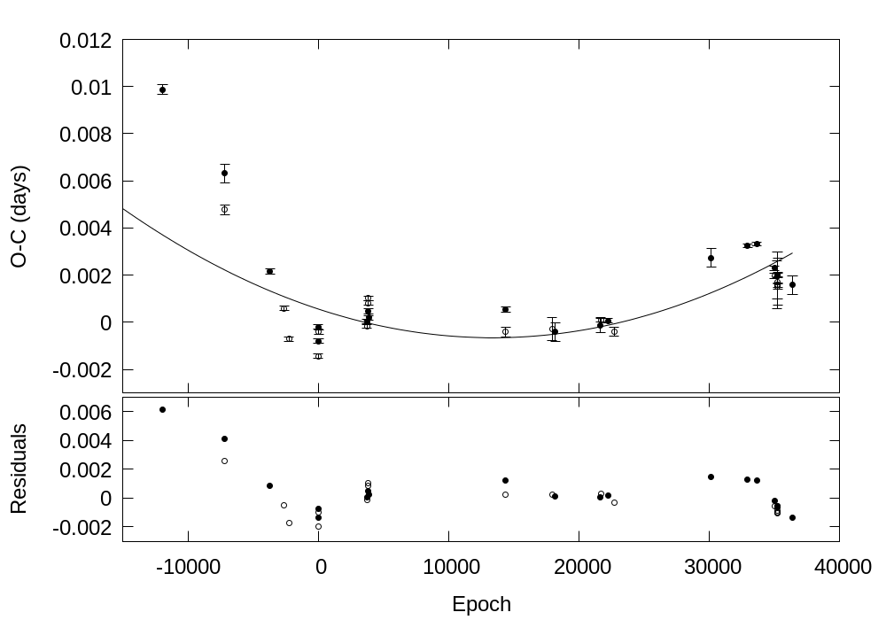
Fig. 1 The quadratic trend on the data points and their residuals. Primary and secondary minimums are indicated as filed and open circles respectively.

Since this fitting does not seem to generate random residuals, we noted that the O-C plot show two large scale secular variations. One downward trend is seen before E < 0, while a less pronounced ascendant tendency is present for E >= -0.5. In this way we assay with simple linear fittings to each of these branches and obtaining the following two ephemeris:

Min. I (BJD_{TDB}) = (2448056.89891 +/- 0.00051) + (0.30231759 +/- 1.1 x 10⁻⁷) x E [days] [3]

Min. I (BJD_{TDB}) = (2448056.90093 +/- 0.00022) + (0.302318713 +/- 9.4 x 10⁻⁹) x E [days] [4]

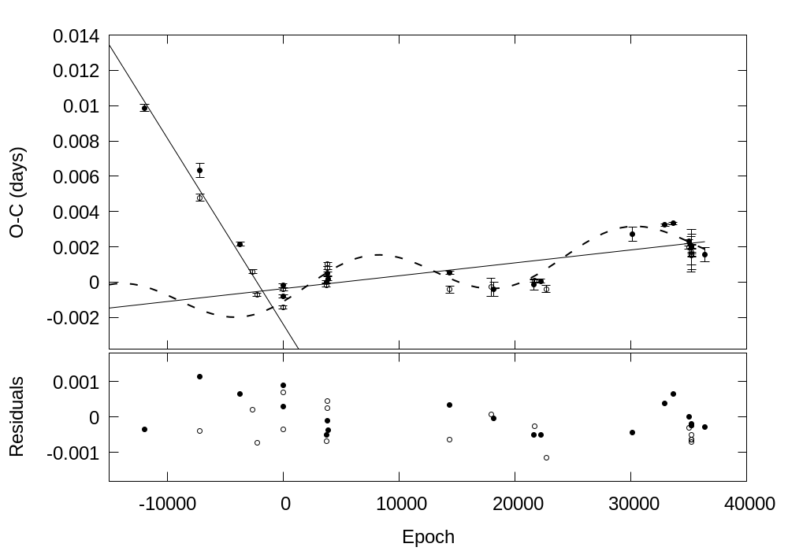
Fig. 2 The two linear ephemeris fittings are represented as solid lines. Dashed line depicts the sinuoidal fitting to the residuals between the data and the linear ephemeris of Eq. 4. In the lower panel, the final residuals after removing the linear trends and the cyclic variation are plotted. Filed and open circles represent primary and secondary minimums.

Both fittings are depicted in Figure 2. As it can be seeing at the bottom of that Figure, the residuals of the first branch fitting do no show any systematic trend. The sum of the squares of the weighted residuals for each linear fitting resulted to be 1479 which is less than half of the sum of the weighted residuals of the overall quadratic fitting 3560 of Eq. 2.
Supposing the new ephemeris of Eq. 3 and 4 are real, each linear branch would correspond to two different constant period stages. For that case, a sudden period jump should have occurred around E ~ 0.
The differences between the periods of Eq. 3 and 4, give us the period jump which resuts to be ΔP = 1.12 x 10⁻⁶ +/- 1.1 x 10⁻⁷. This period increase could be interpreted as a rapid mass transfer from the lower mass star to its companion. Supposing a conservative mass transfer the quantity of mass transferred for this period change could be derived using the following expression (e.g. Negu and Tessema 2015)
$\frac{ΔP}{P}=3ΔM\frac{\left(M_{1}−M_{2}\right)}{M_{1}M_{2}}\left(5\right)$
Considering M₁ and M₂ from Table 5 and the system parameters we obtain the transferred mass to be about ΔM = 3.5 x 10⁻⁰⁶ M⊙

A more detailed inspection to the linear fittings to the data of Figure 2, it looks like the data located at E>=0.5 show an oscillatory behavior around the second branch line. Then, a new adjustment to the residuals between these data and Eq. 4, was made using a sinusoidal function, to get

O-C = (0.0013 +/- 0.0002) x sin ((0.0002838 +/- 5.2 x 10⁻⁶) x E + (-0.578 +/- 0.124)) [days] [5]

The addition of Eq. 4 and 5 is depicted at the top panel of Figure 2. The residuals of the whole fittings are presented at the bottom of the same Figure.

This sinusoidal variation in the O—C diagram of BF Pav presents an amplitude K = 0.00134 +/- 0.00021 d = 115.5 +- 18.1 s and a period of 2πP/(0.0002838 x 365.25) = 18.3 +/- 0.3 yr.
Some hypothesis are commonly used to explain this kind of behavior. If a significant magnetic activity in one of the binary components, the changes in its inner structure during the magnetic activity cycles can cause a spin–orbital coupling producing the cyclic variation of the orbital period. This is known as the Applegate mechanism (Applegate, J.H., 1992. ApJ 385, 621). However, as it will be discussed later, BF Pav does not seem to have significant magnetic activity.
On the other hand, the periodic changes of O-C could also be attributed to the light-time effect, caused to an invisible third body revolving around the binary system (Irwin J.B., 1952. ApJ, 116, 211). We will restrict our analyses to a circular orbit for the third body because the distribution of points of our collection of times of minimum is not good enough to consider detailed eccentric orbits. In this case, the projected semiaxis (a’₁₂ sin i’) of the orbit of the binary around the barycentre of the triple system is given by
a’₁₂ sin i’ = K x c
where i’ is the inclination of the triple system orbit, K is the amplitude of the O—C oscillation (Eq. 5), and c is the speed of light. Thus we obtain a’₁₂ sin i’ = 0.2324 +- 0.037 AU. The mass function ƒ(m) must be used to derive the projected mass of the third body (M₃ sin i’),
ƒ(m) = (4π² /GP₃²) (a’₁₂ sin i’)³ = (M₃ sin i’)³ / (M₁ + M₂ + M₃)², [6]
where P₃ is the period of oscillation of Eq. 5 and G is the gravitational constant.
Thereby, ƒ(m) = 3.69 x 10⁻⁶ +- 1.75x10⁻⁶ M⊙ and the projected mass M₃ sin i’ = 0.026 +/- 0.013 M⊙ = 28 +/- 13 M_{jup}. Even inside the errors, the minimum mass for the third body, for the case for i’ = 90°, is greater or of the order of the lower limit mass for a brown dwarf (~0.014 M⊙).

Hence, if this it should be a giant planet with 60.8 percent probability, and a brown dwarf with 39:2 percent probability (If the Angle distribution is uniform). So the mass of this third body implies that it may be a critical substellar object between brown dwarf and giant planet.

Using the third Kepler law a₃ = [P₃²*(M₁ + M₂ + M₃)]^{1/3} we can derive the semiaxis of the third body orbit. Supposing an orbital inclination of 90°, a₃ = 9.13 +/- 0.33 UA, which is almost 40 the binary separation, which is quite large than the common envelope of the binary.

where $E$ is the cycle number after the reference cycle. Figure 1 shows the O-C diagram calculated using Equation 2. The solid black line represents a quadratic least squares fit to the O-C values. The quadratic ephemeris is given in Equation 3,

$Min.I\left({BJD}_{TDB}\right)=\left(2448056.90292±0.00005\right)+\left(0.302318401±0.000000006\right)×E+$
$\left(0.7171209±0.0019646\right)×{10}^{−11}E^{2}days.\left(3\right)$

We calculate $p´$, the rate of period change, using following formula according to a small quadratic term in the residue O-C,
$\frac{dp}{dE}=2Q\left(4\right)$
It reveals a continuous period increase at a rate of 0.173277$×{10}^{−7}\frac{days}{year}$ which corresponds to a period increase of 0.149 s ${century}^{−1}$. The fitted quadratic trend in O-C was derived with OCFit code and the residual of the quadratic term is shown in Figure 2.

4. LIGHT CURVE ANALYSIS
We used the Wilson-Devinney code (Wilson and Devinney 1971), to analyze the light curves. We preferred to use the W-D code combined with the Monte Carlo simulation to determine the uncertainties of the adjustable parameters (Zola et al. 2004, 2010).
The mass ratio of the system could be obtained by the q-search method in the photometric observations, so we did it according to the required standards (Rucinski 2005).
The (B-V) color index is the difference in magnitudes between two wavelength filters B and V. The blue and visual magnitudes are measured through filters centered at 442 nm and 540 nm, respectively. Passing light through different filters depends on the star's surface temperature according to the Planck Law radiation distributions. It means that by having data of the Blue and Visual filters we can calculate the (B-V) index and obtain a good estimation of a star’s surface temperature by it (Poro et al. 2020).
The fraction of detected flux of wavelength depends on the telescope mirrors, the bandwidth of filters, and the response of the photometer, thus it is necessary to correct our data by calibration with the comparison stars from standard catalogs.
Many studies presented relations between the (B-V) index and the surface temperature of the star such as Code et al. (1976), Sekiguchi and Fukugita (2000), and Ballesteros (2012). Eker et al. (2018) presented relations and tables for different parameters of the main-sequence stars. Eker et al. (2018) selected absolute parameters of 509 main-sequence stars from the components of detached-eclipsing spectroscopic binaries in the solar neighborhood that are used to study Mass-Luminosity (ML), Mass-Radius (MR), and Mass-Temperature (MT) relations. They combined the photometric data of Sejong Open cluster Survey (SOS) and typical absolute parameters adjusted from the ML, MR, and MT relation functions calibrated in their study. ‘Sejong Open cluster Survey (SOS) is a photometry project of a large number of clusters in the SAAO Johnson-Cousins’ UBVI system by Sung et al. (2013).
Based on our data and after calibrating (Høg et al. 2000), we calculated (B-V)_{BF Pav} = 0^{m}.803. As a result, based on Eker et al. (2018), the effective temperature of the primary component found to be 5201 $K$.
Sekiguchi and Fukugita (2000) derived a (B-V) color-temperature relation too. They present T_{eff} as a function of (B-V) color index to represent the metallicity value in four classes. By combining the previous results from Eker et al. (2018) and exerting the results of Sekiguchi and Fukugita (2000), the metallicity (Fe/H) value for the primary component of BF Pav can be estimated between -0.75 and -0.25 dex (star’s population II). As shown in Figure 3, obtained temperature from derived (B-V) color is also in an acceptable range (4800 $K$ - 5300 $K$) for the primary component of BF Pav with the method of Sekiguchi and Fukugita (2000).

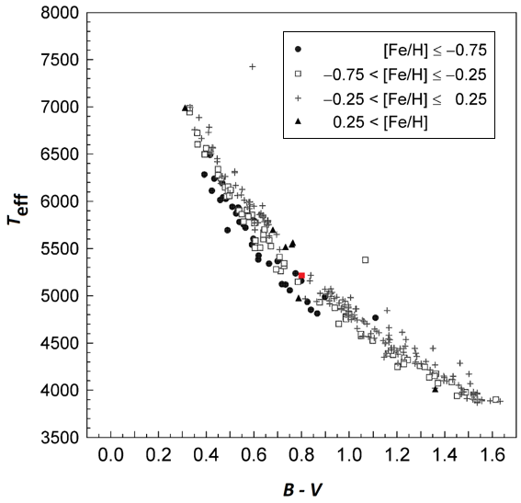
Fig. 3 BF Pav’s position (red dot) based on the Sekiguchi and Fukugita (2000) results.

We assumed gravity-darkening coefficients $g_{1}=g_{2}=0.32$ (Lucy 1967), bolometric albedo $A_{1}=A_{2}=0.5$ (Rucinski 1969), and linear limb darkening coefficients taken from tables published by Van Hamme (1993) in the light curve analysis.
As can be inferred from the light curves, the mean minimum occurred first, and also the temperature of the primary star is higher than the secondary. Based on the unequal minimums, and the logical light curve solutions, mode 3 was chosen for analysis. The parameters obtained from the solutions are given in Table 3. The mean fractional radii of components were calculated with the formula, r_{mean} = (r_{back} × r_{side} × r_{pole})^{1/3} (5).

Table 3 Photometric solutions of BF Pav.
Parameter | Results (with a spot) | Results (without spot)
T₁ (K) | 5201(13) | 5201(13)
T₂ (K) | 4980(20) | 4944(19)
$Ω$₁=$Ω$₂ | 4.4073(297) | 4.5438(193)
$i$ (deg) | 89.31(49) | 89.62(46)
$q$ | 1.459(20) | 1.561(13)
l₁/l_{tot}(B) | 0.478(3) | 0.474(2)
l₂/l_{tot}(B) | 0.522 | 0.526
l₁/l_{tot}(V) | 0.470(3) | 0.465(2)
l₂/l_{tot}(V) | 0.530 | 0.535
l₁/l_{tot}(R) | 0.462(3) | 0.456(2)
l₂/l_{tot}(R) | 0.538 | 0.544
l₁/l_{tot}(I) | 0.455(3) | 0.447(2)
l₂/l_{tot}(I) | 0.545 | 0.553
$A_{1}=A_{2}$ | 0.50 | 0.50
$g_{1}=g_{2}$ | 0.32 | 0.32
$f\left(\text{\%}\right)$ | 9.9 | 12.5
$r$₁(back) | 0.383 | 0.379
$r$₁(side) | 0.347 | 0.343
$r$₁(pole) | 0.331 | 0.327
$r$₂(back) | 0.449 | 0.457
$r$₂(side) | 0.417 | 0.425
$r$₂(pole) | 0.394 | 0.401
$r$₁(mean) | 0.354(2) | 0.350(2)
$r$₂(mean) | 0.420(3) | 0.428(2)
Colatitude_{spot} (deg) | 28(6)
Longitude_{spot} (deg) | 0(1)
Radius_{spot} (deg) | 27(4)
$T$_{spot}/$T$_{star} | 0.80(2)
$∑$ | 0.004 | 0.004
Phase Shift | 0.001(1) | 0.001(1)
Note: Parameters of a star spot is on the primary component.

The observed and synthetic light curves in BVRI filters with residuals show in Figure 4.

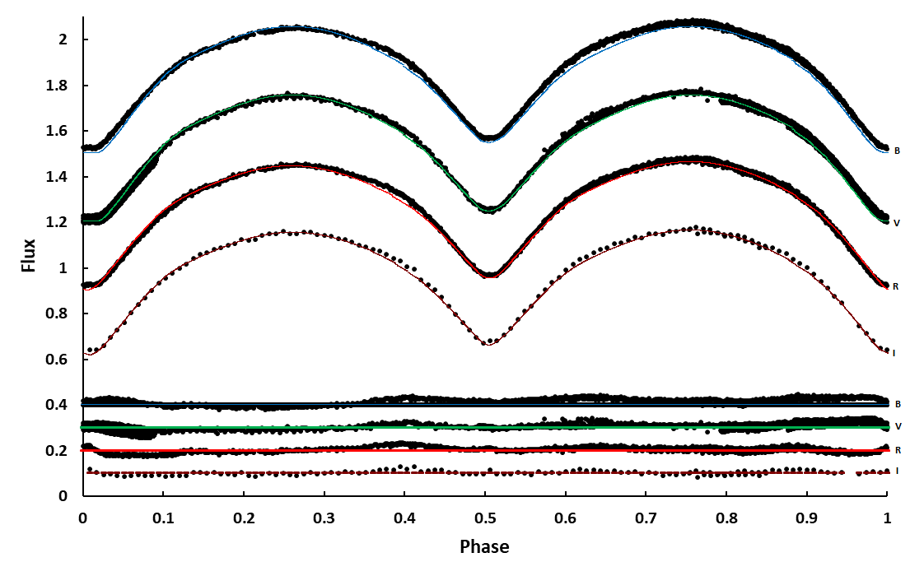
Fig. 4 Observed light curves of BF Pav (points) and modeled solutions (lines) in the BVRI filter from top to bottom, respectively, and residuals are plotted; with respect to orbital phase, shifted arbitrarily in the relative flux.

Fillout factor is a quantity that indicates the degree of contact in the binary star systems defined by Mochnacki & Doughty (1972) and Lucy & Wilson (1979) that was modified and redefined by David H. Bradstreet (2005),

$f=\frac{Ω\left(L_{1}\right)−Ω}{Ω\left(L_{1}\right)−Ω\left(L_{2}\right)}\left(6\right)$

where $Ω.Ω\left(L_{1}\right)$ ,and $Ω\left(L_{2}\right)$are star surface potential, inner Lagrangian surface potential, and outer Lagrangian surface potential, respectively. We calculated a fillout factor of 9.9% with a cold spot and 12.5% without spot from the output parameters of the light curve solutions.

A difference in the heights of the maxima in light curves of eclipsing binary systems indicates the O'Connell effect (O'Connell 1951). This binary system appears to demonstrate this effect because we need to add a spot on the primary component in the light curve solutions. Table 4 represents the characteristic parameters of the light curves of BF Pav.

Table 4 Characteristic parameters of the light curves in the BVRI filters.
Part of LC. | B | V | R | I
MaxI - MaxII | 0.032 | 0.005 | 0.027 | 0.011
MaxI - MinI | -1.052 | -0.982 | -0.920 | -0.879
MaxI - MinII | -0.868 | -0.820 | -0.783 | -0.780
MinI - MinII | 0.184 | 0.162 | 0.137 | 0.099

The M_{(primary)} is derived from a study by Eker et al. (2018), and M_{(secondary)} is calculated by $q=\frac{M_{2}}{M_{1}}$ (7). We also calculated the mass of each component of the binary system using the method of Harmanec (1988) who derived a simple approximation formula relating absolute parameters (mass, radius and luminosity) to the effective temperature of the components based on data analyzing. For this purpose, we used the following formula,

$log\frac{M}{M_{ʘ}}=\left(\left(1.771141X−21.46965\right)X+88.05700\right)X−121.6782$ (8)

where $X$ is log(T_{eff}). This formula is only defined in the range of 4.62 ≥ log(T_{eff}) ≥ 3.71 (Harmanec 1988). So we calculated M₁ as the mentioned range is valid for primary T_{eff} of BF Pav due to our photometric solution. The absolute parameters are given in the Table 5 and there is a high conformity between the results which were obtained by two methods.

Table 5 Estimated absolute parameters of BF Pav by two methods to calculate the mass of the primary component.
Parameter | Eker et al. (2018) |  | Harmanec (1988)
 | Primary | Secondary | Primary | Secondary
Mass (M⊙) | 0.914 | 1.333(21) | 0.906(18) | 1.322(18)
Radius (R⊙) | 0.878(56) | 1.042(53) | 0.876(56) | 1.039 (54)
Luminosity (L⊙) | 0.506(72) | 0.599(62) | 0.504(61) | 0.598(69)
M_{bol} (mag) | 5.48(15) | 5.30(15) | 5.48(15) | 5.30(15)
log g (cgs) | 4.512(44) | 4.527(42) | 4.510(44) | 4.526(42)
a (R⊙) | 2.482(5) |  | 2.475(5)

According to the estimated absolute parameters of this binary system, the distance was calculated. We obtained $m_{V}=12.674\left(25\right)$ from our light curve and $M_{V}=5.661\left(30\right)$ for primary component (${BC}_{1}=−0.181$ from Eker et. al. 2018). So the distance to the binary system computed from the formula,

$d_{\left(pc\right)}={10}^{\left(\frac{m_{pri}−M_{pri}+5−A_{V}}{5}\right)}\left(9\right)$

Therefore, an estimate of the distance of this binary system is $243±18$ parsec (using with $A_{V}=0.08$ (Schlafly and Finkbeiner 2011).

The 3D view of BF Pav and the Roche lobe configuration of BF Pav illustrated in Figure 5.

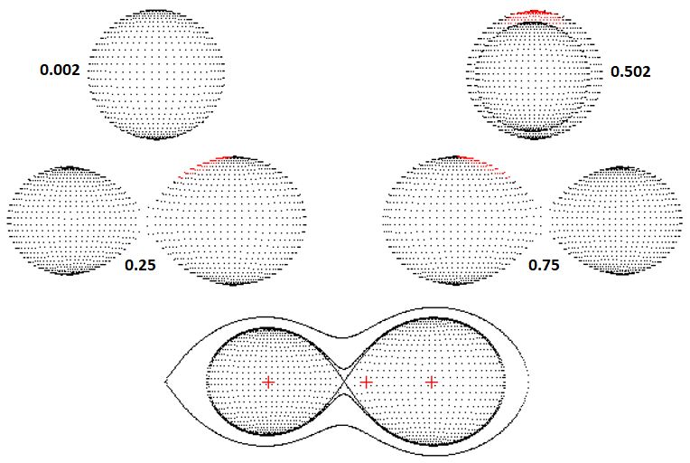
Fig. 5 The positions of the components of BF Pav.

5. RESULT AND CONCLUSION
The photometric observations of BF Pav were carried out during eight nights utilizing BVRI filters. This study’s approach is to present a new ephemeris and light curve analysis of the W UMa‐type eclipsing binary BF Pav and probe this binary system’s period changes. According to the O-C analysis, we obtain a period increase at a rate of $0.173277×{10}^{−7}\frac{days}{year}$.
We specified the photometric solution of the short period system BF Pav based on the Wilson-Devinney code combined with the MC simulation to calculate the uncertainties of the searched parameters. We obtained a mass ratio ($q=\frac{M_{2}}{M_{1}}$) of $1.459±0.020$ from q-search which suggested that BF Pav is a contact binary, a fillout factor (f), and an inclination (Table 3). Also, the difference between this binary system components’ temperature $∆T$ in the order of 200 $K$. We calculated the binary system distance which is equals to $243±18$ pc and this result is in good agreement with the Gaia DR2 value $255.084±2.770$ pc.
Based on the estimation of absolute parameters, the diagrams of the Mass-Luminosity (M-L) and the Mass-Radius (M-R) on a log-scale show the evolutionary status of BF Pav. The theoretical ZAMS and TAMS lines and the positions of the primary and secondary components are depicted in Figure 6. Since the W UMa-type eclipsing binaries are known as the Low-Temperature Contact Binaries (LTCBs), the difference between the temperatures of two components are close to each other and typically around 5%; and this is about 4% for BF Pav. As discussed by Yakut & Eggleton (2005), in this type of contact binary system the luminosity of some primary is transferred to the secondary because of their initial masses. Moreover, in W UMa-type eclipsing binaries the components share a common convective envelope, so the primary component is near to the zero-age main sequence (Figure 8-a). This is taken to mean that the primary is not yet evolved. Alternatively, the deviation of the secondary component shows it is slightly evolved from ZAMS. The secondary components show different evolutionary paths due to more initial masses than the present masses (Yildiz &amp; Doğan, 2013). According to the amount of the mass ratio, the fillout factor, and the inclination, which comply with Gonzalez et al. (1996) results, we suggest that BF Pav is a W-type system. Yildiz and Doğan (2013) investigated the parameters of W-type W UMa binaries to estimate initial masses of these stars which were obtained based on MESA models (Paxton 2010) due to mass transfer between two components. According to the mass loss model of Yildiz and Doğan (2013) and clearly from Figure 8, on the log M - log L diagram, the location of both components of BF Pav appearance to be in good agreement with the distribution of primary and secondary stars of the W-type W UMa binary systems.

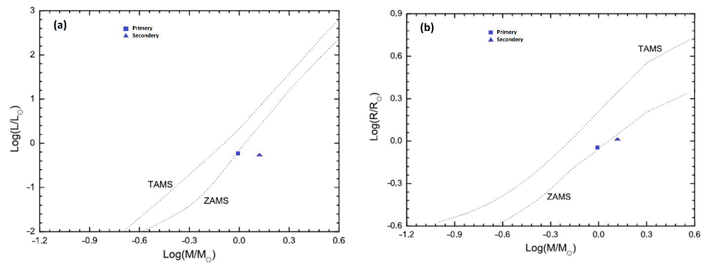
Fig. 6 The log M - log L, and log M - log R diagrams for BF Pav from the absolute parameters. The dashed lines represent the TAMS and ZAMS and the locations of the primary and secondary components of BF Pav are marked.

Stellar winds are the major responsible for the binary system’s mass loss due to the star’s magnetic activities. According to the Table 4 and maxima differences in the light curves, it seems that BF Pav does not have significant magnetic activity and this implies a negligible O'Connell effect in this binary system and we fetched up that the mass loss idea is void for this system, so we concentrate on mass transfer. Based on the third Kepler law ($p^{2}=\frac{4π^{2}}{G\left(M_{1}+M_{2}\right)}a^{3}\left(10\right)$), by considering the angular momentum conservation law, we used the following formula (Negu and Tessema 2015):

$\frac{\overset{´}{p}}{p}=3\overset{´}{M_{1}}\frac{\left(M_{1}−M_{2}\right)}{M_{1}M_{2}}\left(11\right)$

According to our results, the secondary star mass is more than primary star mass ($M_{2}>M_{1}$ and also $\overset{´}{p}>0$from our O-C analysis, so we derive that $\overset{´}{M_{1}}<0$, thus the mass transfer is from the primary star to the secondary star, which causes $\overset{´}{a}>0$ that means the orbit enlarges and the angular frequency $\left(\frac{\overset{´}{ω}}{ω}=\frac{−\overset{´}{p}}{p}\left(12\right)\right)$ decreases.
BF Pav had been observed by Hoffman (1981) but the observer has not been able to prosecute a detailed analysis due to lack of data. After a while, the first detailed photometric analysis of BF Pav was performed in 1996 using the Wilson-Devinney code (Gonzalez et al. 1996) after UBV photoelectric observations of this binary system between 1987 and 1993 in the observational program of southern short-period eclipsing binaries. The former photometric solution demonstrates that BF Pav has a mass ratio of 1.4 while we calculated $q=1.459±0.020$. To complete our comparison, we found 9.9% for the amount of fillout factor whereas 10% was obtained for f in the prior study. The temperature of the primary star reported as 5430 $K$ in the first photometric solution whereas we found it to be 5201 $K$ concerning the upper temperature limit value for this binary system’s primary star is 5200 $K$ in Gaia DR2. According to the amount of the mass ratio, the fillout factor, and the inclination, which are in compliance with Gonzalez et al (1996) results, we also suggest that BF Pav is a W-type system.

Acknowledgments This manuscript is based on the Binary Systems of South and North Project (http://bsnp.info). The project aims to study contact binary systems in the northern and southern hemispheres of several observatories in different countries.

References
[1] Ballesteros, F.J., 2012. New insights into black bodies. EPL (Europhysics Letters), 97(3), p.34008. https://doi.org/10.1209/0295-5075/97/34008.

[2] Bradstreet, D.H., 2005, May. Fundamentals of solving eclipsing binary light curves using Binary Maker 3. In Society for Astronomical Sciences Annual Symposium (Vol. 24, p. 23).

[3] Code, A.D., Bless, R.C., Davis, J. and Brown, R.H., 1976. Empirical effective temperatures and bolometric corrections for early-type stars. The Astrophysical Journal, 203, pp.417-434. https://doi.org/10.1086/154093.

[4] Collins, K.A., Kielkopf, J.F., Stassun, K.G. and Hessman, F.V., 2017. AstroImageJ: Image processing and photometric extraction for ultra-precise astronomical light curves. The Astronomical Journal, 153(2), p.77. https://doi.org/10.3847/1538-3881/153/2/77.

[5] Davoudi, F., Jafarzadeh, S.J., Poro, A., Basturk, O., Mesforoush, S., Harandi, A.F., Gozarandi, M.J., Mehrjardi, Z.Z., Maley, P.D., Khakpash, S. and Rokni, K., 2020. Light curve analysis of ground-based data from exoplanets transit database. New Astronomy, 76, p.101305. https://doi.org/10.1016/j.newast.2019.101305.

[6] Dryomova, G.N. and Svechnikov, M.A., 2006. Variation in the orbital period of W UMa-type contact systems. Astrophysics, 49(3), pp.358-369. https://doi.org/10.1007/s10511-006-0036-9.

[7] Eker, Z., Bakış, V., Bilir, S., Soydugan, F., Steer, I., Soydugan, E., Bakış, H., Aliçavuş, F., Aslan, G. and Alpsoy, M., 2018. Interrelated main-sequence mass–luminosity, mass–radius, and mass–effective temperature relations. Monthly Notices of the Royal Astronomical Society, 479(4), pp.5491-5511. https://doi.org/10.1093/mnras/sty1834.

[8] George, D.B., 2000. Image Processing With Maxim DL Software. International Amateur-Professional Photoelectric Photometry Communications, 79, p.2.

[9] Gonzalez, J.F., Lapasset, E., Gomez, M. and Ahumada, J., 1996. Photometric Analysis of the Contact Binary BF Pavonis. Publications of the Astronomical Society of the Pacific, 108(722), p.338. https://doi.org/10.1086/133727.

[10] Harmanec, P., 1988. Stellar masses and radii based on modern binary data. Bulletin of the Astronomical Institutes of Czechoslovakia, 39, pp.329-345.

[11] Hoffmann, M., 1981. Photoelectric Photometry of BF Pavonis. Information Bulletin on Variable Stars, 1935.

[12] Høg, E., Fabricius, C., Makarov, V.V., Bastian, U., Schwekendiek, P., Wicenec, A., Urban, S., Corbin, T. and Wycoff, G., 2000. Construction and verification of the Tycho-2 Catalogue. Astronomy and Astrophysics, 357, pp.367-386.

[13] Juryšek, J., Hoňková, K., Šmelcer, L., Mašek, M., Lehký, M., Bílek, F., Mazanec, J., Hanžl, D., Magris, M., Nosál, P. and Bragagnolo, U., 2017. BRNO Contributions# 40 Times of minima. OEJV, 179, p.1.

[14] Kreiner, J.M., 2004. Up-to-date linear elements of eclipsing binaries. Acta Astronomica, 54, pp.207-210.

[15] Kwee, K. and Van Woerden, H., 1956. A method for computing accurately the epoch of minimum of an eclipsing variable. Bulletin of the Astronomical Institutes of the Netherlands, 12, p.327.

[16] Lucy, L.B., 1967. Gravity-darkening for stars with convective envelopes. Zeitschrift fur Astrophysik, 65, p.89.

[17] Lucy, L.B. and Wilson, R.E., 1979. Observational tests of theories of contact binaries. The Astrophysical Journal, 231, pp.502-513. https://doi.org/10.1086/157212.

[18] Mochnacki, S.W. and Doughty, N.A., 1972. A Model for the Totally Eclipsing W Ursae Majoris System AW UMa. Monthly Notices of the Royal Astronomical Society, 156(1), pp.51-65. https://doi.org/10.1093/mnras/156.1.51.

[19] Negu, S.H. and Tessema, S.B., 2015. Mass Transfer in Binary Stellar Evolution and Its Stability. International Journal of Astronomy and Astrophysics, 5(03), p.222. https://doi.org/10.4236/ijaa.2015.53026.

[20] O'Connell, D.J.K., 1951. The so-called periastron effect in eclipsing binaries. Monthly Notices of the Royal Astronomical Society, 111(6), pp.642-642. https://doi.org/10.1093/mnras/111.6.642.

[21] Okamoto, I. and Sato, K., 1970. The formation of W Ursae Majoris stars. Publications of the Astronomical Society of Japan, 22, p.317.

[22] Poro, A., Davoudi, F., Basturk, O., Esmer, E.M., Aksaker, N., Akyüz, A., Aladağ, Y., Rahimi, J., Lashgari, E., Ghanbarzadehchaleshtori, M. and Modarres, S., 2020. The First Light Curve Solutions and Period Study of BQ Ari. arXiv preprint arXiv:2006.00528.

[23] Paxton, B., Bildsten, L., Dotter, A., Herwig, F., Lesaffre, P. and Timmes, F., 2010. Modules for experiments in stellar astrophysics (MESA). The Astrophysical Journal Supplement Series, 192(1), p.3.

[24] Qian, S., 2003. Are overcontact binaries undergoing thermal relaxation oscillation with variable angular momentum loss?. Monthly Notices of the Royal Astronomical Society, 342(4), pp.1260-1270. https://doi.org/10.1046/j.1365-8711.2003.06627.x.

[25] Qian, S.B., Zhang, J., He, J.J., Zhu, L.Y., Zhao, E.G., Shi, X.D., Zhou, X. and Han, Z.T., 2018. Physical Properties and Evolutionary States of EA-type Eclipsing Binaries Observed by LAMOST. The Astrophysical Journal Supplement Series, 235(1), p.5.

[26] Rucinski, S.M., 1969. The proximity effects in close binary systems. II. The bolometric reflection effect for stars with deep convective envelopes. Acta Astronomica, 19, p.245.

[27] Rucinski, S.M., Pych, W., Ogłoza, W., DeBond, H., Thomson, J.R., Mochnacki, S.W., Capobianco, C.C., Conidis, G. and Rogoziecki, P., 2005. Radial velocity studies of close binary stars. X. The Astronomical Journal, 130(2), p.767. https://doi.org/10.1086/431226.

[28] Schlafly, E.F. and Finkbeiner, D.P., 2011. Measuring reddening with Sloan Digital Sky Survey stellar spectra and recalibrating SFD. The Astrophysical Journal, 737(2), p.103. https://doi.org/10.1088/0004-637X/737/2/103.

[29] Sekiguchi, M. and Fukugita, M., 2000. A Study of the B− V Color-Temperature Relation. The Astronomical Journal, 120(2), p.1072. https://doi.org/10.1086/301490.

[30] Shapley, H, Boyce, E., and Boyd, C. 1939, Harvard Ann., 90.

[31] Smith, R.C., 1984. The theory of contact binaries. Quarterly Journal of the Royal Astronomical Society, 25(4), pp.405-420.

[32] Spencer Jones, J.H., 1988. The W UMa Stars AB Tel and BF Pav. IBVS, 3265, p.1.

[33] Stępień, K., 2006. Evolutionary Status of Late-type Contact Binaries: Case of a 1.2+ 1 M⊙ Binary. Astrophysics and Space Science, 304(1-4), pp.81-84.

[34] Sung, H., Lim, B., Bessell, M.S., Kim, J.S., Hur, H., Chun, M.Y. and Park, B.G., 2013. Sejong open cluster survey (SOS). 0. Target selection and data analysis. arXiv preprint arXiv:1306.0309. https://doi.org/10.5303/JKAS.2013.46.3.103.

[35] Van Hamme, W., 1993. New limb-darkening coefficients for modeling binary star light curves. The Astronomical Journal, 106, pp.2096-2117. https://doi.org/10.1086/116788.

[36] Wilson, R.E. and Devinney, E.J., 1971. Realization of accurate close-binary light curves: application to MR Cygni. The Astrophysical Journal, 166, p.605.

[37] Yakut, K. and Eggleton, P.P., 2005. Evolution of close binary systems. The Astrophysical Journal, 629(2), p.1055.

[38] Yang, Y.G. and Qian, S.B., 2015. Deep, low mass ratio overcontact binary systems. XIV. a statistical analysis of 46 sample binaries. The Astronomical Journal, 150(3), p.69. http://doi:10.1088/0004-6256/150/3/69.

[39] Yildiz, M. and Doğan, T., 2013. On the origin of W UMa type contact binaries–a new method for computation of initial masses. Monthly Notices of the Royal Astronomical Society, 430(3), pp.2029-2038.

[40] Zhang, L., Pi, Q., Han, X.L., Li, T., Zhang, X., Sang, H., Wang, D. and Wang, S., 2015. The first multi-color photometric study of the short-period contact eclipsing binary GK Aqr. New Astronomy, 38, pp.50-54. https://doi.org/10.1016/j.newast.2015.02.002.

[41] Zola, S., Gazeas, K., Kreiner, J.M., Ogloza, W., Siwak, M., Koziel-Wierzbowska, D. and Winiarski, M., 2010. Physical parameters of components in close binary systems–VII. Monthly Notices of the Royal Astronomical Society, 408(1), pp.464-474. https://doi.org/10.1111/j.1365-2966.2010.17129.x.

[42] Zola, S., Rucinski, S.M., Baran, A., Ogloza, W., Pych, W., Kreiner, J.M., Stachowski, G., Gazeas, K., Niarchos, P. and Siwak, M., 2004. Physical parameters of components in close binary systems: III. Acta Astronomica, 54, pp.299-312.

http://simbad.u-strasbg.fr/simbad/
http://vizier.u-strasbg.fr/viz-bin/
https://github.com/pavolgaj/OCFit
https://www.cosmos.esa.int/web/gaia/dr2

